**RESEARCH ON**

**DEEP LEARNING,**

**NEURAL NETWORK**

**AND**

**NEURAL STYLE TRANSFER (NST)**

**By- Ayesha I. Mokamjiwala 18-BCA-093**

**Udit Shroff 18-BCA-118**

INDEX

|  |  |  |
| --- | --- | --- |
| Sr. No. | Topic | Page No |
| 1 | Abstract | 3 |
| 2 | Introduction | 4 |
| 3 | Literature Review | 7 |
| 4 | Review Findings | 16 |
| 5 | Problem Formulation | 17 |
| 6 | Mathematical Background | 18 |
| 7 | Methodology-Research Objective- System Design | 22 |
| 8 | Result and Analysis | 32 |
| 9 | Conclusion | 37 |
| 10 | Scope for future work | 38 |
| 11 | References | 40 |
| 12 | Appendix | 42 |

**Abstract**

In the following pages we have covered working of deep learning and artificial neural networks as well as researching Neural Style Transfer which is the main focus of this study. It explains how neural networks are formed and how they learn from old information and predict new information. Neural style transfer is an interesting new concept regarding image style recognition and reapplication where we generate a third image by merging features from 2 distinct images.

We have elaborated on how it merges the two images, and how it is able to pull features from them to be reapplied in resulting image. It gives us an idea on how Neural networks can be used for visual perception and creating new art work like images. All the practical implementation is done in Python 3. We have used PyTorch technology in neural style transfer as a base for working bit tensors.

**Introduction**

Neural networks, along with deep learning, have been around for quite some time, and they've only started picking up now and impacting the world right now. If you look back at the '80s you'll see that, even though they were invented in the '60s and '70s, they really caught onto a trend in the '80s. People started talking about them a lot, there was a lot of research in that area, and everybody thought that deep learning or neural networks were this new thing that is going to impact the world, and then it kind of slowly died off over the next decade. The reason is that they were just not good enough, because of the fact that technology back then was not up to the right standard to facilitate neural networks. In order to work with neural network, you need two things. The first thing is data and the second thing is processing power.

If we compare these across the board and, without even taking price and size into consideration, just the capacity of whatever was trending at the time, so from 1956 to 1980 capacity increased about double (5 Megabytes to 10 Megabytes) and then it increased about 51,200 times (512 Gigabytes). And the length of the period is not that different, from 1956 to 1980 is 24 years, from 1980 to 2019, 39 years, so not that much of an increase in time but a huge jump in technological progress, and that stands to show that this is not a linear trend, this is an exponential growth in technology. And if we take into account price and size, the increase will be in millions. Right now, you can get storage on cloud which doesn't cost you anything. In fact, over the years, this is going to go even further. Right now, scientists are even looking into using DNA for storage. So, that shows how quickly we're progressing and why deep learning is picking up; now that we are finally at the stage where we have enough data to train remarkable superlative models.

And the second thing we talked about is processing capacity. We are entering the era of computers that are extremely powerful, that can process things way faster than we can imagine, and that is what is facilitating deep learning.

Geoffrey Everest Hinton, cognitive psychologist and computer scientist, did research on deep learning in the '80s. He has published lots of research papers on deep learning. He has worked on projects for Google Brain and University of Toronto and is currently the Co-founder and Chief Scientific Advisor of the Vector Institute of Toronto. His most noted works are in the field of Artificial Neural Networks and he is often referred to as 'Godfather of Deep Learning'.

The idea behind deep learning is to mimic how the human brain operates and recreate it. It imitates the workings of the human brain in processing data and creating patterns for use in decision making. It has the capability of learning from data that is unstructured or unlabelled even

while unsupervised.

**What is Neural Network?**

The human brain is one of the most powerful tools on this planet for learning and adapting skills, and then applying them. There are approximately 100 billion neurons in the human brain, and each neuron is connected to as many as about a 1,000 of its neighbors. We recreate this in a computer by creating an artificial structure called an artificial neural network (ANN) where we have a circuit composed nodes, or neurons, connected to each other to simulate cognitive modelling. These nodes are connected and pass information through synapses with the help ofweights. This is inspired by the biological neural systems and how they process data to make decisions.

**What is Neural Style Transfer?**

In fine art, especially painting, humans have mastered the skill to create unique visual experiences through composing a complex interplay between the content and style of an image. Here we introduce an artificial system based on a Deep Neural Network that creates artistic images of high perceptual quality. The system uses neural representations of biologically inspired vision models to separate and recombine content and style of arbitrary images, providing a neural algorithm for the creation of artistic images. Moreover, in light of the striking similarities between performance-optimised artificial neural networks and biological vision, our work offers a path forward to an algorithmic understanding of how humans create and perceive artistic imagery.1 This technique allows us to synthesize new images combining the content and style of different images. Several developments have been made in this sub-field but the most notable initial work was done by Leon Gatys in 2015.

**Literature Review**

**Deep learning methods:**

Deep learning methods are a group of machine learning methods that can learn features hierarchically from lower level to higher level by building a deep architecture. The deep learning methods have the ability to automatically learn features at multiple levels, which makes the system be able to learn complex mapping function directly from data, without the help of the human-crafted features. The most characterizing feature of deep learning methods is that their models all have deep architectures. A deep architecture means it has multiple hidden layers in the network. In contrast, a shallow architecture has only a few hidden layers (1 to 2 layers). Deep Convolutional Neural networks are successfully applied in various areas. Regression, Classification, dimensionality reduction, modeling motion, modeling textures, information retrieval, natural language processing, robotics, fault diagnosis, and road crack detection.2

**Nodes and Synapses:**

An ANN is comprised of a network of artificial neurons (also known as "nodes"). These nodes are connected to each other, and the strength of their connections to one another is assigned a value based on their strength: inhibition (maximum being -1.0) or excitation (maximum being +1.0). If the value of the connection is high, then it indicates that there is a strong connection. Within each node's design, a transfer function is built in. There are three types of neurons in an ANN, input nodes, hidden nodes, and output nodes, divided by a layered structure.4

The input nodes take in information, in the form which can be numerically expressed. The information is presented as activation values, where each node is given a number, the higher the number, the greater the activation. This information is then passed throughout the network. Based on the connection strengths (weights), inhibition or excitation, and transfer functions, the activation value is passed from node to node. Each of the nodes sums the activation values it receives; it then modifies the value based on its transfer function. The activation flows through the network, through hidden layers, until it reaches the output nodes. The output nodes then reflect the input in a meaningful way to the outside world. The difference between predicted value and actual value (error) will be propagated backward by apportioning them to each node's weights according to the amount of this error the node is responsible 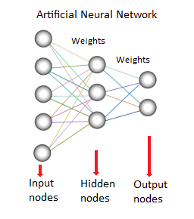for.4

Figure 3.1: Working of Artificial Neural Network

Image Source: [www.saedsayad.com](http://www.saedsayad.com)

**Activation Functions:**

Activation functions are mathematical equations that determine the **output** of a neural network. The function is attached to each neuron in the network, and determines whether it should be activated (“fired”) or not, based on whether each neuron's **input** is relevant for the model's prediction.5

There are lots of activation functions in neural networks.

Some of them are mentioned below:

**Threshold Functions:**

The threshold functions are very simple type have a function where if the value is less than zero then the threshold function passes on zero. If the value is more than zero or equal to zero then threshold function passes on a one.

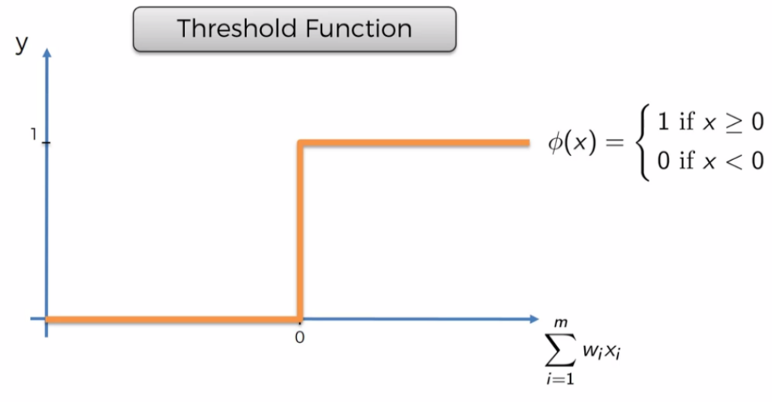 Figure 3.2: Graphical representation of Threshold Function

Image Source: [Google images](https://www.google.co.in/imghp#spf=1598827550844)

**Sigmoid Function:**

In this case, x is the value of the weighted sums. It's a function which is used in the logistic regression. This function has a smooth gradual progression, unlike the threshold function. Anything below zero, it drops off. Above zero, it approximates towards one. Sigmoid functions are very useful in the final output layer when we're trying to predict probabilities.

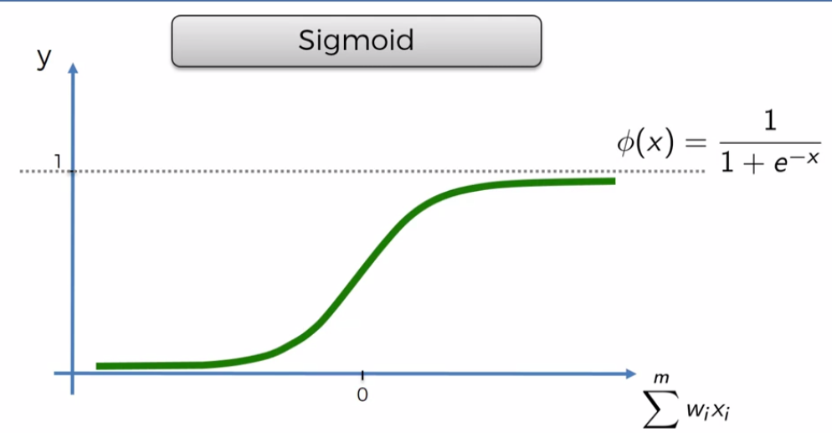

Figure 3.3: Graphical representation of Sigmoid Function

Image Source: [Google images](https://www.google.co.in/imghp#spf=1598827550844)

**Hyperbolic Tangent Function:**

It's very similar to the sigmoid function but here the hyperbolic tangent function goes below zero. The values go from zero to one, or approximately to one and go from zero to minus one on the other side, which can be useful in some applications.

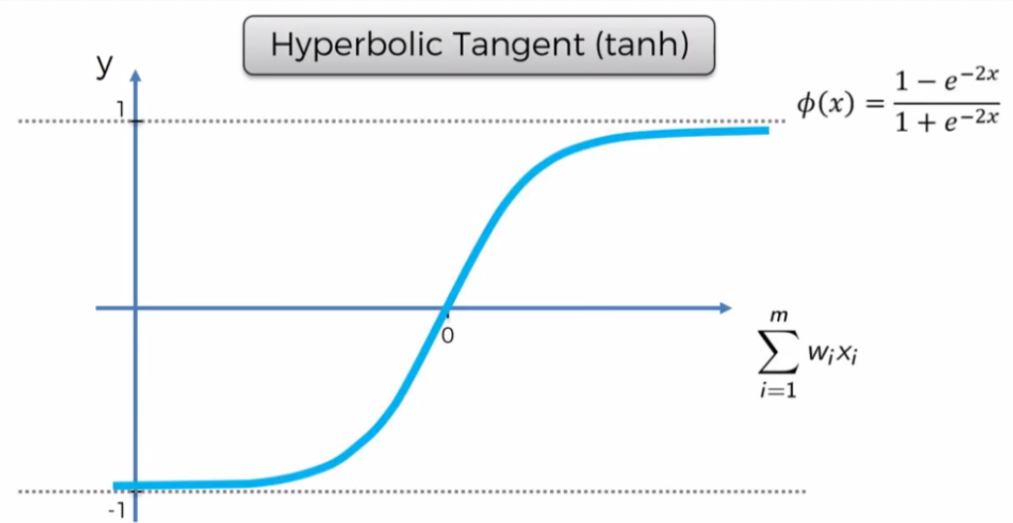

Figure 3.4: Graphical representation of Hyperbolic Tangent Function

Image Source: [Google images](https://www.google.co.in/imghp#spf=1598827550844)

**Rectifier Function:**

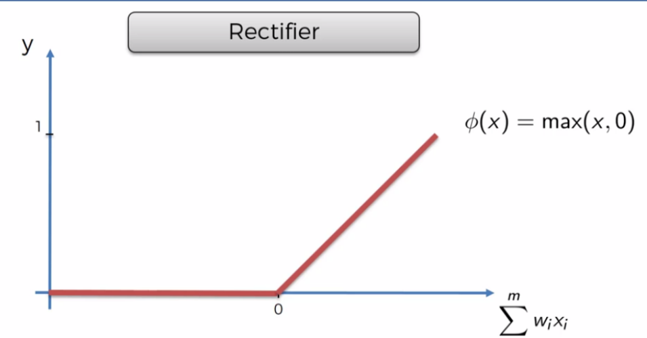Rectifier function is one of the most popular functions for artificial neural networks. It goes all the way to zero and it gradually progresses as the input value increases.

Figure 3.5: Graphical representation of Rectifier Function (Image Source: [Google images](https://www.google.co.in/imghp#spf=1598827550844))

**Back Propagation:**

After calculating the error, we need to analyze how each of the weights affect the resultant error and adjust these weights accordingly. Back propagation is an advanced algorithm which allows us to adjust the weights simultaneously, instead of manually trying to understand the weights and adjusting individual weights in the network.

**Cost Function:**

In order to be able to learn, the neural network compares its output value to the actual value in the training sets. The difference tells us the error in our prediction in a quantified manner. Calculating this difference is done by the cost function of the network. The network's goal is to minimize this cost function, because a lower cost function indicates a smaller difference between the predicted output and the expected output.

**NST Through Pretrained Models:**

In a deep neural network, where hundreds of layers are involved, one face the serious problem of vanishing gradients in which the accuracy of the model decreases with the increase in the number of layers. Hence, efficient networks like ResNet, DenseNet, VGG-Net, etc. were introduced. It is difficult and very time consuming to build dense neural network from scratch for every problem, and ResNet, DenseNet, and VGG-Net are some of the state-of-the-art networks that have been quite successful.

Pre-trained models are built using transfer learning techniques, where the model uses knowledge to solve a problem (i.e., recognizing a boat) and applies it to a related but similar problem (recognizing a ship).

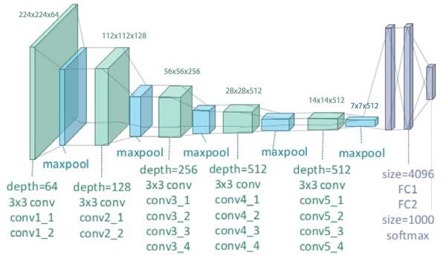The VGG-Net model can recognize low-level features using shallow (earlier) layers and high-level features using deeper layers.3

Figure 3.6: The layer structure of the VGG-19 Network

Image Source: [Google images](https://www.google.co.in/imghp#spf=1598827550844)

### **VGG Architecture:**

Instead of using large filters with larger strides, this model uses smaller filters.

The convolution layers in VGG have the responsibility to separate the style and content of an image. Considering the fact that deeper layers in the network capture the objects and their arrangement in the input image, these are complex features to extract. And near the final layers of the CNN, the best features are found.3

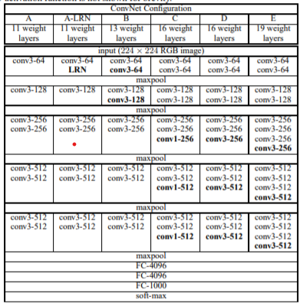

Figure 3.7: Variants of Architecture of VGGNet-19 Model

[Image Source: arxiv.org](https://arxiv.org/pdf/1409.1556.pdf)

## **Loss Function:**

## In style transfer, a neural network is not trained. Instead, its weights and biases are kept constant, and an image is updated by changing/modifying the pixel values until the loss function is optimized (reducing the losses). It makes sure that the "content" in the content image and the "style" in the style image are present in the generated image.6

In Neural Style Transfer, we are generating a new image from two images, so we need more loss functions to generate a new image.6

Some of the loss functions are:

* Content loss
* Style loss
* Total Variation loss

## **Content Loss:**

This function helps to check how similar the generated image is to the content image. It gives the measure of how far (different) are the features of the content image and target image. The Euclidean distance is calculated.6

## **Style Loss:**

## Style Loss measures how different the generated image, in terms of style features, is from your style image. But it's not as straightforward as content loss. The style representation of an image is given by Gram Matrix.6

### **Total Variation Loss:**

Variation loss was introduced to avoid highly noisy outputs and overly pixelated results. The main purpose of variation loss is to maintain smoothness and spatial continuity.6

## **Gram Matrix:**

Gram Matrix is only concerned with whether the stylish features are present in image weights, textures, and shapes. Hence, it is the best choice. The Gram Matrix G is the set of vectors in a matrix of dot products. For a particular layer, the diagonal elements of the matrix will find how active the filter is. An active filter will help the model find whether it contains more horizontal lines, vertical lines, or textures.

To get the results, the matrix is multiplied by its transposed matrix.

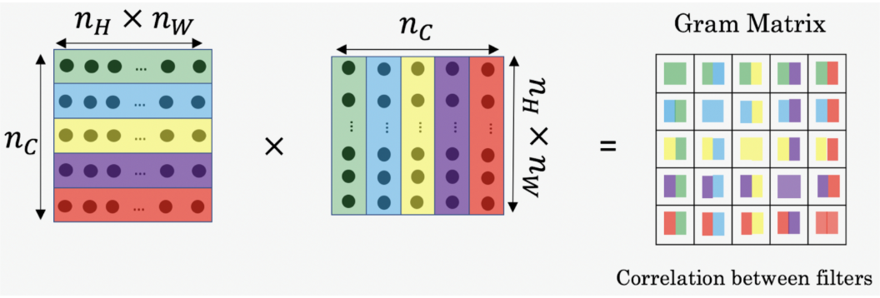

Figure 3.8: Gram Matrix

[Source: deeplearning.ai](https://www.deeplearning.ai/)

**Review Finding**

In today's world neural network have become common application when it comes to decision making predicting outcomes, developing strategies etc. But here we are using a neural network for creating and perceiving artistic imagery. The style transfer algorithm can be used to modify existing images to the user's liking which would be rather difficult if otherwise pursued manually.

Training of a new model is not required, instead we use highly efficient pre trained image recognition models to lift content and style from images. These are then transferred to a third image where it goes through many iterations of image modification, trying to minimize style and content loss. The result will be a stylized combination of two images, which will exhibit the content of one image while absorbing style of the other image. The algorithm tries to arrive at an optimum result by iteratively minimizing style loss and content loss. The result is pulled from between the layers while still being processed, the data in the output layer is deemed redundant. The main aim is to provide the user with a satisfying visual stimulus.

**Problem Formulation**

The lack of easily available program where the user can modify their images to their own liking; one where it does more than change colours and hues, it studies the style of an image and tries to apply the same to another given image. Most publicly available style transfer software only let us use pretrained image styles and going through each can take a lot of processing time before arriving at a result which may be deemed satisfactory by the user. In this case the user can provide their own arbitrary style reference image and get a satisfactory result within their range of expectation. The user can use their human ability to perceive the artistic imagery to create unique visual experiences and create an expected result in their minds before attempting the style transfer, which saves a lot of time for the user by giving them the ability to select the style too, against only being able to select the content image and choosing from a limited number of styles.

**Mathematical Background**

**Cost Function:**

Cost Function to calculate the normalized error while training the network:

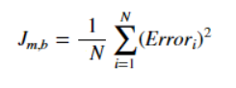

Image Source: [www.geeksforgeeks.org](http://www.geeksforgeeks.org)

* **J** – Cost function
* **N** – number of iterations
* **m, b** – parameters where, y = mx + b

## **Batch Gradient Descent and Stochastic Gradient Descent:**

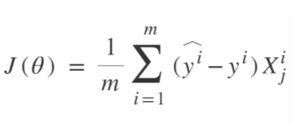Batch Gradient Descent involves calculations over the full training set at each step. It is very computationally expensive; however, this is great for convex or relatively smooth error manifolds.

Image Source: [www.geeksforgeeks.org](http://www.geeksforgeeks.org)

* **J(θ)** - cost function
* **m** - size of training set
* **i** - ith record
* **j** - jth feature
* **ŷ** - prediction
* **y** - actual value
* **X** - training set

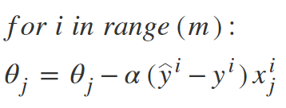Stochastic Gradient Descent uses whole training data to calculate gradients at each step. It picks up a random instance of training data at every step and then computes the gradient making it much faster as there is much fewer data to manipulate at a single time.

Image Source: [www.geeksforgeeks.org](http://www.geeksforgeeks.org)

* **α** – weight

## **Content Loss:**

It is a summation of the difference between the content of the content image and the generated image multiplied by the content weight.

## 

[Image Source: deeplearning.ai](https://www.deeplearning.ai/)

## **Style Loss:**

It is a summation of the difference between the gram matrix of the style image and the generated image multiplied by the style weight.

## 

[Image Source: deeplearning.ai](https://www.deeplearning.ai/)

## **Gram Matrix:**

Gram matrix is a set of vectors in a matrix of dot products multiplied by its transpose

The following is the equation of gram matrix:

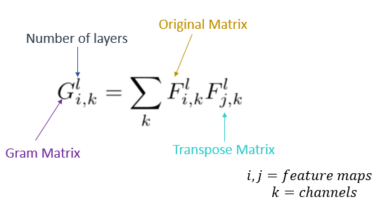

[Image Source: deeplearning.ai](https://www.deeplearning.ai/)

### **Total Variation Loss:**

It is a combination of the style loss and the content loss in the generated image to calculate the total variation loss.

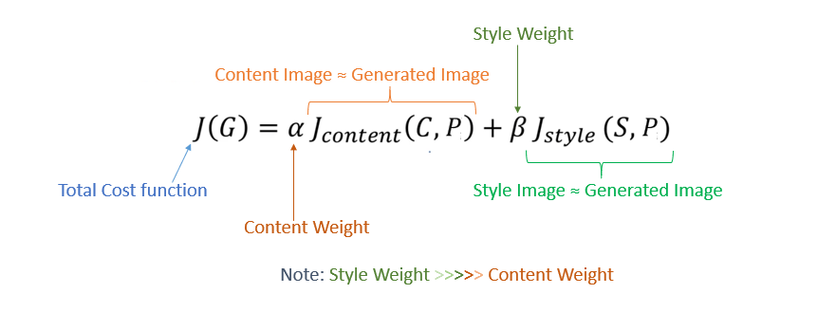

[Image Source: deeplearning.ai](https://www.deeplearning.ai/)

## **Methodology-Research Objective- System Design**

**How does a Neural Network Work?**

Neural networks are very helpful in finding patterns that are too complex for being manually extracted and taught to recognize to the machine. These patterns are introduced to the neural network by the input layer that has one neuron for each component present in the input data and is communicated to one or more hidden layers present in the network. All the processing happens in these hidden layers through a system of connections characterized by weights and biases: the input is received, the neuron calculates a weighted sum adding also the bias and according to the result and a pre-set activation function, it decides whether it should be ‘fired’ or activated. Afterwards, the neuron transmits the information downstream to other connected neurons in a process called ‘forward pass’. At the end of this process, the last hidden layer is linked to the output layer which has one neuron for each possible desired output. We can vary the weights and the bias to obtain distinct models of decision-making. We can assign more weight to those inputs so that if they are positive, it will favor our desired output.7

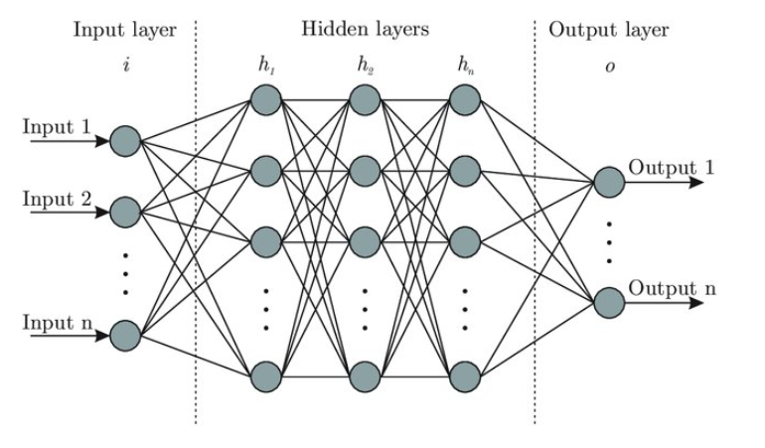

Figure 7.1: Basic design of an Artificial Neural Network

Image Source: [researchgate.net](https://www.researchgate.net/publication/321259051_Prediction_of_wind_pressure_coefficients_on_building_surfaces_using_Artificial_Neural_Networks/figures?lo=1)

**How does a Neural Network Learn?**

The weights are randomly initialised to small numbers close to 0 (but not 0). The first observation of the dataset is fed into the input layer. Each input node represents one feature. The neurons are activated from left to right; the impact of each neuron's activation is limited by the weights. Forward Propagation of the activations is exercised until prediction y is obtained. The predicted result is compared to the actual result and their error is computed. The weights are updated during back-propagation according to how much they are responsible for the error. The magnitude of weight adjustment is decided by the learning rate. This process is repeated until the whole training set passed through the ANN. This constitutes one epoch; the learning process iterates through many such epochs calculating complex patterns in data along the way.

**Difference Between Batch Gradient Descent and Stochastic Gradient Descent:**

1. Batch Gradient Descent computes gradient using the whole Training sample

Stochastic Gradient Descent computes gradient using a single Training sample

1. Batch Gradient Descent is slow and computationally expensive algorithm

Stochastic Gradient Descent has faster and less computationally expensive than Batch Gradient Descent

1. Batch Gradient Descent is not suggested for huge training samples.

Stochastic Gradient Descent can be used for large training samples.

1. Batch Gradient Descent is deterministic in nature.

Stochastic Gradient Descent is stochastic in nature.

1. Batch Gradient Descent gives optimal solution given sufficient time to converge.

Stochastic Gradient Descent gives good solution but not optimal.

1. Batch Gradient Descent has no random shuffling of points are required.

The data sample in Stochastic Gradient Descent should be in a random order, and this is why we want to shuffle the training set for every epoch.

1. Batch Gradient Descent can’t escape shallow local minima easily.

Stochastic Gradient Descent can escape shallow local minima more easily.

1. In Batch Gradient Descent, convergence is slow.

Stochastic Gradient Descent reaches the convergence much faster.

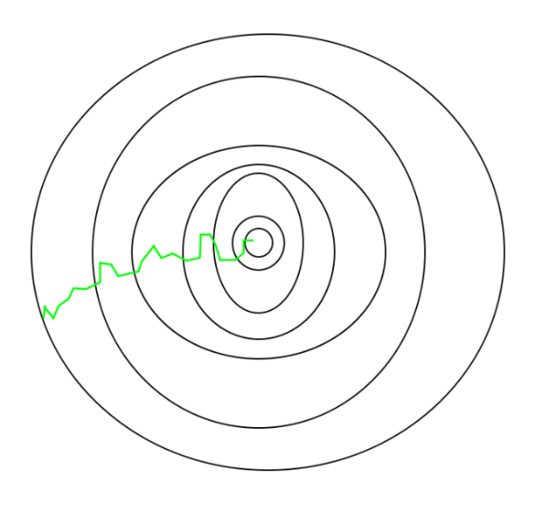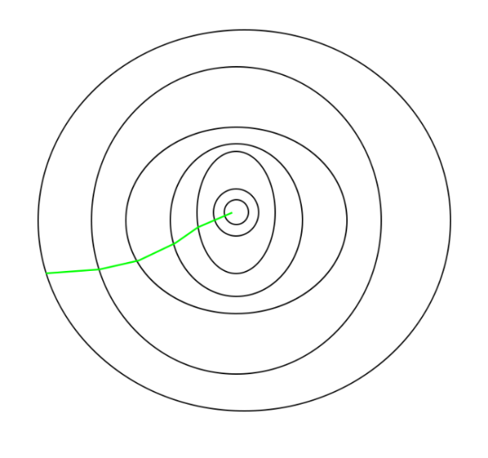

Figure 7.2: Path taken by Batch Gradient Descent Figure 7.3: Path taken by Stochastic Gradient Descent

Image Source: [www.geeksforgeeks.org](http://www.geeksforgeeks.org)

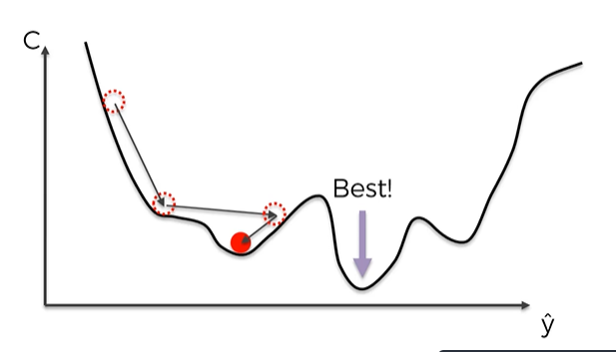

Figure 7.4: Example of Batch Gradient Descent being trapped in a local minima

Image Source: [Google images](https://www.google.co.in/imghp#spf=1598827550844)

**Ideology of Neural Style Transfer:**

Our ability to abstract content from style might be a sign of the powerful inference capability of our visual system. This method of synthesising images that mix content and style from different sources, provides a new, fascinating tool to study the perception and neural representation of art, style and content-independent image appearance in general. We can design novel stimuli that introduce two independent, perceptually meaningful sources of variation: the appearance and the content of an image. We envision that this will be useful for a wide range of experimental studies concerning visual perception ranging from psychophysics over functional imaging to even electrophysiological neural recordings. In fact, our work offers an algorithmic understanding of how neural representations can independently capture the content of an image and the style in which it is presented. Importantly, the mathematical form of our style representations generates a clear, testable hypothesis about the representation of image appearance down to the single neuron level. The style representations simply compute the correlations between different types of neurons in the network.1

Extracting correlations between neurons is a biologically plausible computation. The results suggest that performing a complex-cell like computation at different processing stages along the ventral stream would be a possible way to obtain a content-independent representation of the appearance of a visual input.

Incidentally, image recognition models like VGG-19 are trained to perform one of the core computational tasks of biological vision, automatically learns image representations that allow the separation of image content from style. The explanation could be that when learning object recognition, the network has to become invariant to all image variation that preserves object identity. Representations that factorise the variation in the content of an image and the variation in its appearance would be extremely practical for this task.1

**Implementation:**

This implementation of neural style transfer is using PyTorch technology.

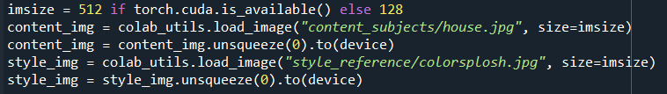

Here, we are setting the size of the images according to our processing power.

We are loading and resizing images by using their local path and optimizing them for further processing

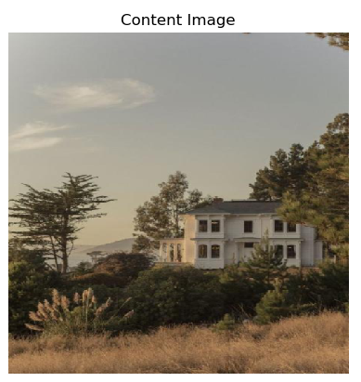

Figure 7.5: Content Image before resize Figure 7.6: Content Image after resize

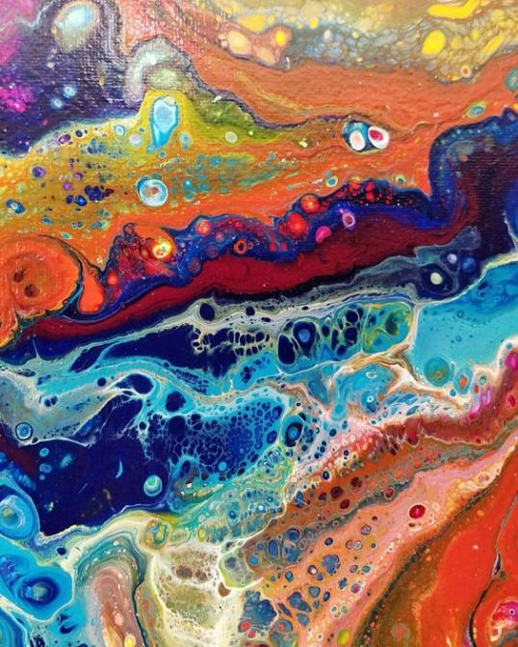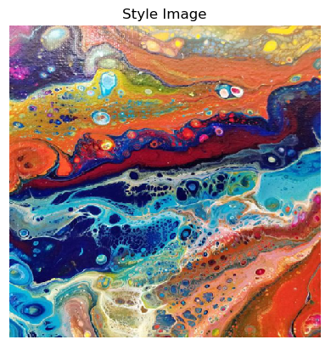

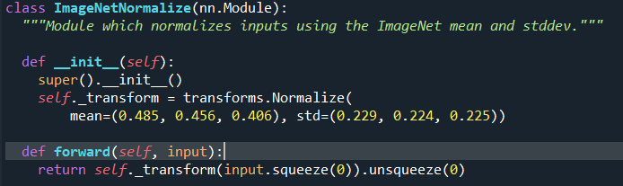 Figure 7.7: Style Image before resize Figure 7.8: Style Image after resize

This module is used to normalize inputs using the ImageNet Mean and Standard Deviation

## Class to calculate Content Loss

## Class to calculate Style Loss



Listing intermediate layers that we are interested in for style reference and content reference.

## 

## Getting model and losses of Style transfer.

Iterating through a loop while performing style transfer. It also calculates style loss and content loss after each iteration to calculate total variation loss which it tries to minimize with every iteration.

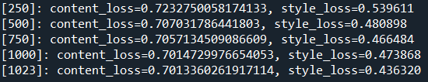

The program updates us with the Style and content losses at fixed intervals.

We can observe that through the iterations, both Style loss and Content loss are being minimized.

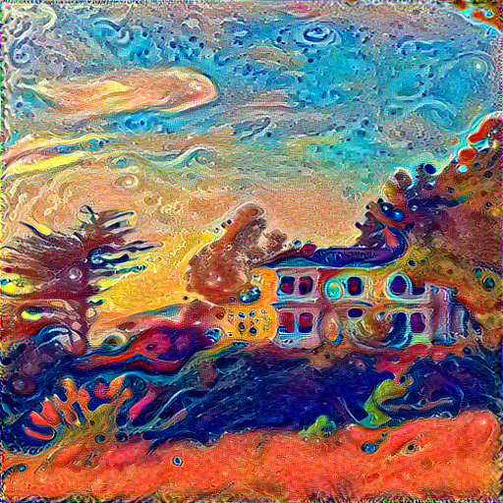

Figure 7.9: Final result

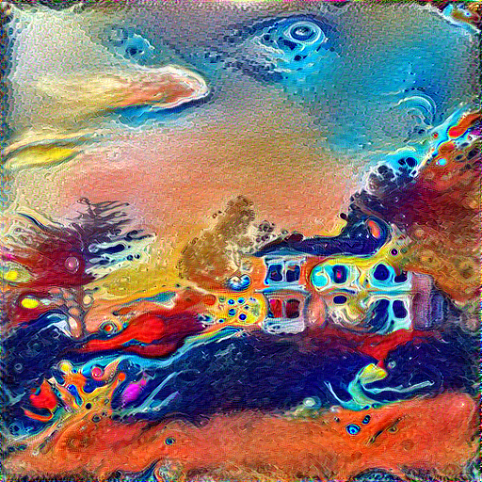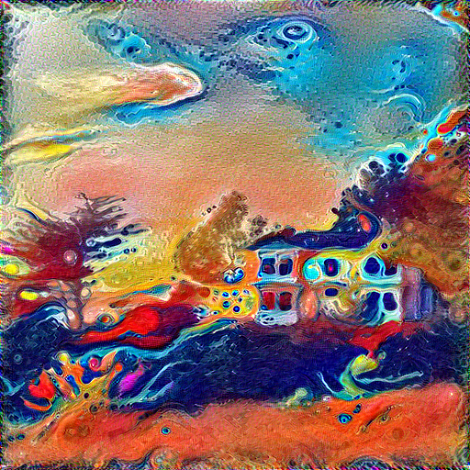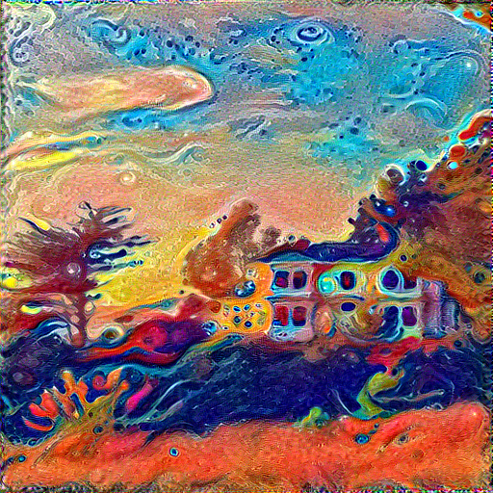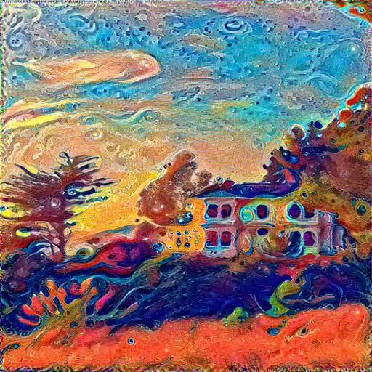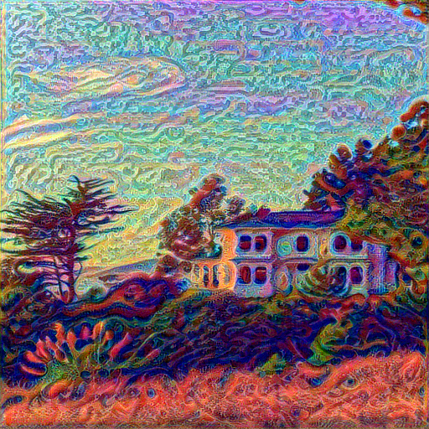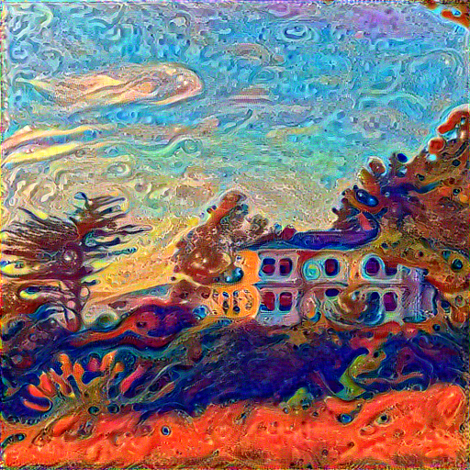

Iteration 25

Iteration 10

Iteration 50

Iteration 100

Iteration 1000

Iteration 500

We can observe that the changes during the prior iterations are more drastic while they seem to be more subtle and refine in the later iterations.

**Result and Analysis**

**Implementation Results:**

These are some of our implementation on the following images:

**1.Starrynight and Adams Creation:**

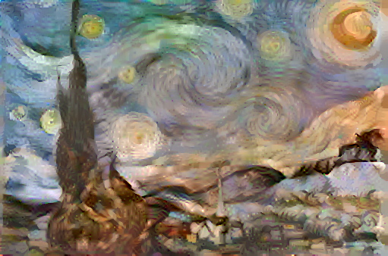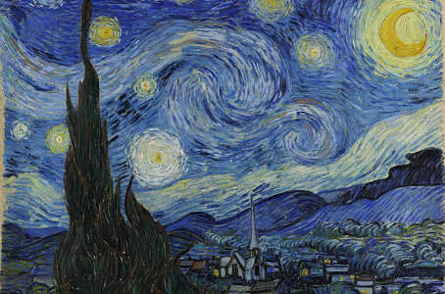

Content Image

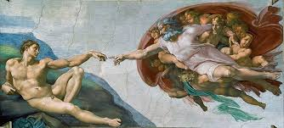

Generated Image

Style Image

**2. Pillars of Creation and Seated Nude:**

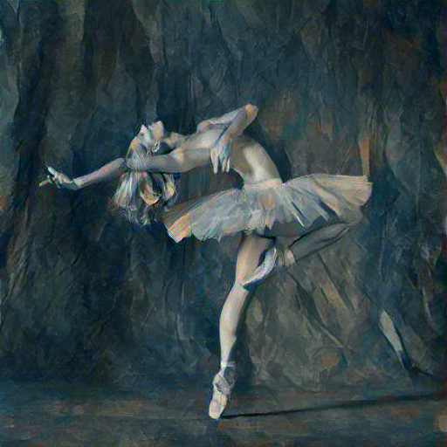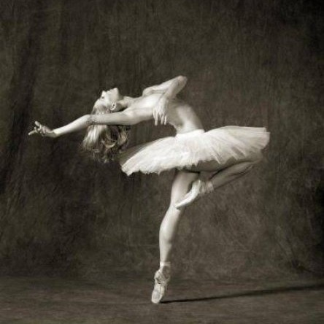

Content Image

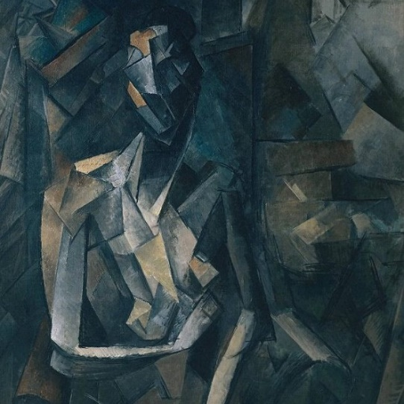

Generated Image

Style Image

**3. Pillars of Creation and Nebula:**

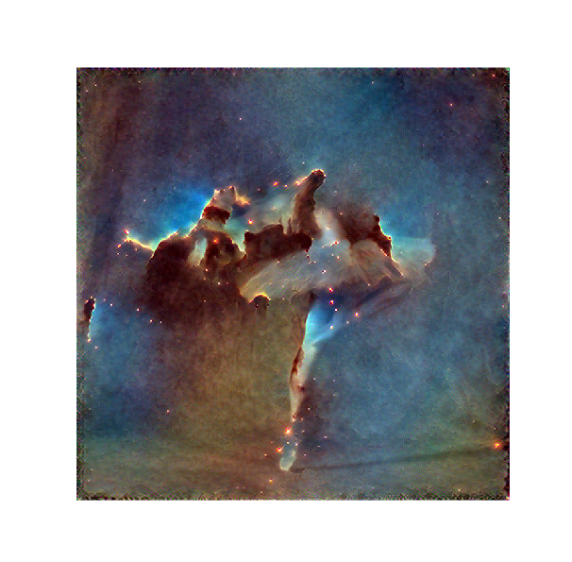

Content Image

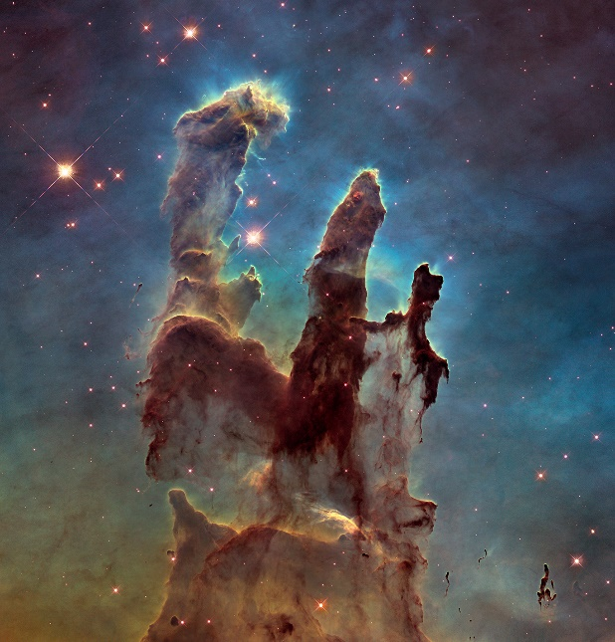

Generated Image

Style Image

**Analysis of Deep learning and Neural Networks:**

**Cognitive Ability:**

We have analyzed by learning about the working of deep learning and neural networks that how they find patterns using their cognitive ability to learn from data, behaving very similarly to an actual neurological system.

**Predictions:**

Being able to predict accurate outcomes from unforeseen data using what it learned previously.

**Black Box:**

We never know how or why neural network came up with certain outcome, what factor it used and how it used them. Because of this, important decisions cannot be trusted on the outcome of the neural network.

**Data Requirement:**

It requires a lot of data to train a neural network before it can give highly accurate results. This data needs to be properly recorded and preprocessed over a long period of time.

**Analysis on Neural Style Transfer:**

**Time:**

As of right now the time cost of generating a single image is a bit high. This is due to the arbitrary nature of the inputs.

**Quality and Processing Power:**

The image quality that we are working right now is enough for prototyping but can be unsatisfactory for the real scenario. This limitation is due to lack of processing power available to a person on an average.

**Convolutional Layer relu3_2 instead of Convolutional layer relu4_2:**

We found better results with the use of Convolutional layer relu3_2 as the content layer rather than Convolutional layer relu4_2. Because in the latter style overpowers the content and many fine details get washed out.

**PyTorch instead of TensorFlow:**

Using PyTorch technology, we have found that the time consumed to generate the result is remarkably lower than the other recommended technology TensorFlow. It also led to significantly better results.

**Replacing Pooling Layers:**

For image synthesis we found that replacing the max-pooling operation by average pooling improves the gradient flow and one obtains slightly more appealing results.1

**Conclusion**

We have concluded that although neural networks are able to simulate brain activity, their functionality is very limited. They can only work on specifically designed data and give specific range of outputs. Unlike a human brain, it cannot think abstract thoughts and can only work on the information that is provided to it.

Neural style transfer as a subject is new concept regarding artificial neural networks which remain largely undermined. It combines the field of art with the field of artificial intelligence which seems to be very fascinating and create its own unique styles of image modification. The neural style transfer algorithm delves really deep into the domain of content recognition and extraction from images.

**Scope for future work**

**For Neural Style Transfer:**

* **Time Complexities:**

The current given model takes decent amount of time before producing results due to the arbitrary nature of the inputs. The time complexity of the program can be optimised for faster results.

* **Higher Quality Results:**

A more compact but equally efficient Image recognition model can be used to produce higher quality results as the amount of feature maps occupying the memory will be lower and circumvent the problem of memory overflows.

* **Application Interface:**

To provide the program with UI for more user-friendly approach.

* **Program Portability:**

To provide access to the program on any device regardless of their inherent processing power since running the style transfer locally can consume a lot of time on low power devices or result in compromised result quality.

**For Deep Learning and Neural Network:**

* Current growth of DL research and industry applications demonstrate its ubiquitous presence in every facet of AI — be it NLP or computer vision applications.
* With growth in technology and research opportunities, unsupervised learning methods may deliver models that will closely mimic human behavior.
* The future ML and DL technologies must demonstrate learning from limited training materials, and transfer learning between contexts, continuous learning, and adaptive capabilities to remain useful.
* Hundreds of industries could feasibly use neural nets to operate more efficiently, target new audiences, develop new products, or improve consumer safety—yet it’s criminally underutilized. Wider acceptance, wider availability, and more creativity from engineers and marketers have the potential to apply neural nets to more applications.

**References**

1. Leon A. Gatys, Alexander S. Ecker, Matthias Bethge - A Neural Algorithm of Artistic Style.

<https://arxiv.org/abs/1508.06576>

2. Esam Kamal MARIED, Mansour Abdalla ELDALI, Osama Omar ZIADA - A Literature Study of Deep learning and its application in Digital Image Processing <https://www.researchgate.net/publication/317346042_A_Literature_Study_of_Deep_learning_and_its_application_in_Digital_Image_Processing>

3. Gaurav Singhal - Artistic Neural Style Transfer with TensorFlow 2.0, Part 1: Theory

<https://www.pluralsight.com/guides/artistic-neural-style-transfer-with-tensorflow-2.0:-theory>

4.Artificial Neural Network- Data Mining Map

<https://www.saedsayad.com/artificial_neural_network.htm#:~:text=An%20ANN%20is%20comprised%20of,(maximum%20being%20%2B1.0)>

5.What is a Neural Network Activation Function?

<https://missinglink.ai/guides/neural-network-concepts/7-types-neural-network-activation-functions-right/#:~:text=Activation%20functions%20are%20mathematical%20equations,relevant%20for%20the%20model's%20prediction.>

6.Gaurav Singhal - Artistic Neural Style Transfer with TensorFlow 2.0, Part 2: Implementation

<https://www.pluralsight.com/guides/implementing-artistic-neural-style-transfer-with-tensorflow-2.0>

7.Euge Inzaugarat - Understanding Neural Networks: What, How and Why?

<https://towardsdatascience.com/understanding-neural-networks-what-how-and-why-18ec703ebd31>

8. Eugen Hotaj - How to Get Beautiful Results with Neural Style Transfer

<https://towardsdatascience.com/how-to-get-beautiful-results-with-neural-style-transfer-75d0c05d6489>

**Appendix**

Activation Function 8

Back Propagation 11

Content Loss 14

Cost Function 11

Deep Learning 5

Gradient Descent 23

Gram Matrix 14

Layers 7

Neural Network 5

Neural Style Transfer 5

Nodes 7

Style Loss 14

Synapses 7

Total Variation Loss 14

VGG 12

Weights 7